

**TRANSNET CLOUD TECHNOLOGIES**

**Certified AWS Partner**

35 Ajose Adeogun Street Utako Abuja info@transnetcloud.com

**TransnetCloud AWS Cloud Maturity Service Agreement**



# Introduction

**About** **3**

**TransnetCloud** **3**

Global Availability 3

Service Offer 4

Maturity Service 4

Benefits 4

Invoice / Billing Currency 5

Localised Billing Option 5

USD Billing Option 5

How This Works 6

TransnetCloud Cloud Billing Process Flow Diagram 6

Frequently Asked Questions 6

Length of Contract & Contract Termination 7

How to Terminate Contract Your 7

TransnetCloud Support Team Support & 8

Management 8

How to request support / give feedback 8

Request flow 9

Managing your Service 9

Onboarding 9

For Maturity Service Level 10

TransnetCloud Access Requirements 10

**Dispute Resolution** **10**

**Confidentiality** **10**

Overdue / Late Invoice Payments Policy 11

**Governing Law** **12**

# Introduction

The goal of this document is to provide a detailed description about Transnet Cloud AWS Maturity Services capabilities including how to request support, descriptions of our Maturity service level, and an overview of your Transnet Cloud support team.

This AWS Maturity Service Agreement ("Agreement") is made and effective;

BETWEEN: **Transnet Cloud**, a company headquartered in the Abuja, Nigeria and with local presence in over 10 States in Nigeria and operating in compliance with the Federal Republic of Nigeria, with its office located at:

*Nigerian office address*: 35 Ajose Adeogun Street Utako, 900801, Abuja

AND: **IBB Premier Motors**, a company organised and existing under the laws of the Federal Republic of Nigeria, with its head office located at:

Address: *Gwarinpa,  
  
FCT*

**WHEREAS**, **Transnet Cloud** and **IBB Premier Motors** wish to evidence by this agreement the manner in which said confidential and proprietary material will be treated.

## About Transnet Cloud

Transnet Cloud is a global IT company, with offices in Nigeria and sub-offices in over 3 countries. At Transnet Cloud, we help organizations and New Businesses optimize their cloud infrastructure for both performance, security and cost-efficiency. As a trusted and certified AWS partner, we provide scalable solutions tailored to your needs, including cloud infrastructure optimization, digital transformation, cloud migrations, enhanced security, and automated monitoring, as well as offering incentives and support where necessary.

We are a leader in cloud infrastructure, implementation, managed services and training. We’re certified across three audited public clouds - AWS, Microsoft Azure and Google Cloud Platform.

## Global Availability

AWS Maturity Services are available to Transnet Cloud customers in all AWS public regions and AWS GovCloud (US) region. AWS China is not supported. Note that all global support is provided in English.

**Service Offer**

AWS Maturity Services from Transnet Cloud

## Maturity Service

The Maturity service is designed for customers who want to retain a hands-on capability for the configuration and management of their AWS environment, while relying on Transnet Cloud for their AWS monthly billing processing and cost optimization.

At this service level, customers will have access to Transnet Cloud’s cloud security and cost management SaaS platform, Transnet Cloud and AWS cloud cost optimization experts, and any AWS Partner Funding, Discount and Promotional Opportunities Customer might be eligible for. In addition, Customers can process their AWS Bills through Transnet Cloud as their Billing Partners on the AWS platform.

## Benefits

|  |  |
| --- | --- |
| **Services** |  |
| **Simplified Billing & Maturity**  Transnet Cloud can tailor your cloud invoicing process to be aligned to your business requirements. Examples include splitting invoices for chargeback or accounting purpose, consolidating and summarizing invoices. | ✔ |
| **Monthly Cost Optimization Strategy Sessions**  Collaborate with both Transnet Cloud & AWS experts to develop tailored cost optimization strategies, ensuring maximum value from your cloud investments. | ✔ |
| **Cloud Security and Management Platform Access**  Access to Security and Cloud Management Platform | ✔ |
| **Cloud Adoption Support**  Access to sponsored events and webinars to help enable your organization with your cloud transformation. | ✔ |
| **Technical Support**  Access to documentation, white papers and reference architectures cloud platform. | ✔ |
| **Technical Account Manager**  Designated Technical Account Manager to facilitate service onboarding and provide regular service reviews to ensure quality service delivery. Serves as an escalation point for day-to-day operations of your environment. | ✔ |
| **Well Architected Reviews**  Ensure the integrity of your cloud infrastructure with regular Well Architected Reviews, enhancing security, performance, and efficiency, with the possibility of getting $10,000 worth of AWS credits per workload reviewed and remediated. | ✔ |
| **Annual Architecture Review**  Your Technical Account Manager will coordinate an annual Architecture Review of any one workload of your choosing to ensure that you’re leveraging the latest technical and operational best practices. | ✔ |

## Invoice / Billing Currency

Transnet Cloud shall submit invoices not more often than monthly to:

Customer Name: Ola Stephen

Customer email address: olastephenonuh@gmail.com

### Localized Billing Option

AWS bills their customers only in US Dollars, and as part of the Maturity service benefits, Customers have the option to process their AWS bills through Transnet Cloud in NGN.

If this option is taken, Transnet Cloud will use the local currency USD parallel rate of the date the payment is made to calculate and reconcile the payable bill.

All naira payments are to be made into this account: ***Account***

***Name: TranSnet Data and Tech LTD Account***

***Number: 1304511320***

***Bank: Providus Bank***

***Bank Address: FCT, Abuja***

## How This Works

AWS bills AWS Partner (Transnet Cloud) on behalf of Customer. At the end of each month,

Transnet Cloud invoices and bills Customer in Customer’s preferred currency on behalf of AWS. Transnet Cloud Billing Process Flow Diagram

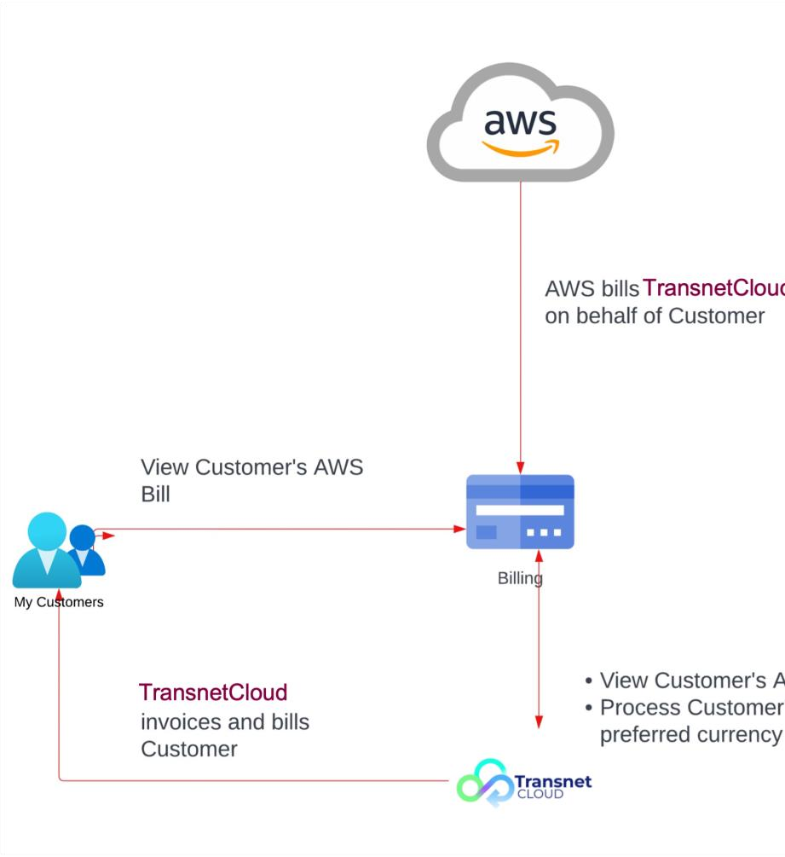

Frequently Asked Questions

1. **Does the customer still have access to view their billing data / usage to ensure the AWS partner is invoicing and billing me the correct amount monthly?** Yes, as the customer, you still have access to view your AWS bills to ensure the right invoice is sent to you by the AWS Partner.
2. **What exchange rate am I to make payment with to the AWS Partner?** The Customer is expected to make payments based on the present day’s (the day the payment is made) exchange rate to the AWS Partner.
3. **How does Transnet Cloud's cloud billing service work?** Transnet Cloud's cloud billing service involves bringing your existing AWS accounts under our Organization

account for streamlined billing and management. This consolidation enables enhanced cost optimization, centralized billing, and improved security.

1. **What about data security and control?** We understand the importance of data security. Our Organization account offers advanced security features such as fine-grained permissions and multi-factor authentication. Your data remains fully under your control while benefiting from heightened security measures.

### 5. Is the AWS account onboarding process complex? No, our onboarding

process is designed to be seamless. We provide step-by-step guidance and support to ensure a smooth transition of your AWS accounts to our Organization account, minimizing disruptions.

1. **Will I lose autonomy over my AWS resources?** No, you'll retain full operational autonomy over your resources. While billing will be centralized, you'll continue to manage and configure your services according to your business needs.
2. **Can I revert to my previous billing structure?** Yes, you have the flexibility to revert to your previous billing structure if desired, in accordance with our contract agreement. We focus on delivering value through cost optimization, security, and streamlined management to encourage continued usage.
3. **Will the onboarding disrupt my operations?** No, invitations to onboard our Organization account will not disrupt your operations.

9.

**Is there a risk of vendor lock-in?** Our service is designed to provide value without creating vendor lock-in. You can choose to revert to your previous billing structure if you decide to discontinue using our service.

10. **If I have an Organization account, can I onboard only a specific set of AWS accounts?** Yes, our service is flexible. You can choose to migrate specific AWS accounts that align with your business goals and needs.

You can learn more here: https://docs.aws.amazon.com/awsaccountbilling/latest/aboutv2/consolidatedbilling.html https://docs.aws.amazon.com/organizations/latest/userguide/orgs_manage_accounts_invit es .html

## Length of Contract & Contract Termination

This contract will last for 12 months from the date the contract is signed………………. After which, both parties can decide to renew the contract.

## How to Terminate Contract

**Termination without cause.** The customer may terminate this agreement for any reason upon 30 (thirty) days written notice to Transnet Cloud

**Termination for cause.** In the event of any material breach of this agreement by either party, the non-breaching party may terminate this agreement immediately by providing a written notice to the other party.

***Effect of Termination.*** If this Agreement is terminated by the customer, the Transnet Cloud shall, within ten (10) business days of receipt of the notice of termination, confirm whether or not payments have been completed by the customer. In the event, payments have not been completed, the ***Overdue/ Late Invoice Payment Policy*** in this agreement will be enforced.

## Your Transnet Cloud Support Team

**Account Manager/Team**

* Your dedicated Account Manager shall be responsible for the following:
* Provide education and guidance around AWS Partner Programs – Funding Programs and Volume Discount Programs
* Responsible for guiding Maturity services customers through the onboarding process
* Monitor and manage the delivery of Maturity services to ensure smooth onboarding, operations and customer satisfaction
* Lead regular service improvement meetings with the customer and any appropriate third parties and documents resulting recommendations in a service improvement plan
* Follow through any actions, issues, and service improvement opportunities highlighted at service review meetings
* Manage the overall execution of the service improvement plan, especially feedback (backed by a team of certified cloud engineers)

●

Act as a point of contact for technical escalations by or for the customer

## Support & Management

How to request support / give feedback

Log an incident, change, or request support using one of the options below.

**Option 1: Log a request by telephone**

Call the Technical Account Manager/Team assigned to you

### Option 2: Log a request by email

Email the cloud team (**info@transnetcloud.com**) and refer to the customer instructions. For all tickets submitted via email, please call your account manager to escalate if necessary.

### Customer Instructions

The support team will prompt you for the following information. Please ensure you have all relevant details ready:

* Your Organization’s Name
* Your Contact Name, Email and Phone Number
* Details of the incident, change, or request

Contact information

Phone: **+234 8127-435-913**

Email: **chigozie@transnetcloud.com**

## Request flow

Service requests submitted by the Customer will follow the path outlined below. If a Customer Runbook has not been created for the request or issue, then a Standard Process will be followed.

Our Standard Process covers requests for information and basic service troubleshooting.

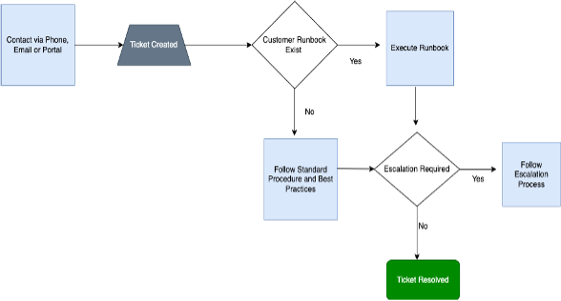

## Managing your Service

Important Processes

### Onboarding

For Transnet Cloud to provide the complete set of services, it is critically important that the onboarding process be performed with precision and detail. The depth of onboarding varies based on service level.

#### For Maturity Service Level

* Capture any billing requirements and chargeback rules if necessary ○ Ensure customer understands how to request support and what support is entitled under the current service level
* Ensure customer can access the Transnet Cloud Security and Cloud Management Portal - Wendu
* Establish a regular service review cadence with your Technical Account Manager/Team
* Ensure Transnet Cloud has all necessary access to systems to provide agreed upon level of service
* Optionally begin scheduling for the annual WAR review

## Transnet Cloud Access Requirements

For any service level where the customer is invoicing their AWS infrastructure and services through Transnet Cloud we require the AWS account to be configured in the following way:

● AWS customer account is part of Transnet Cloud AWS Organization

## Dispute Resolution

I. Any dispute arising out of or in connection with this Agreement shall to the extent possible, be settled amicably by negotiation and discussion between the Parties. If the Parties are unable to settle the dispute amicably within fourteen (14) days of its commencement, such dispute shall be referred to arbitration and settled in accordance with the provisions of the Arbitration and Mediation Act, 2023.

II.

The arbitral tribunal shall comprise a sole arbitrator; and where both Parties are unable to agree on the sole arbitrator within five (5) days of the commencement of the arbitration, either Party shall apply to the Chairman of the Nigerian Branch of the Chartered Institute of Arbitrators, who shall then appoint a sole arbitrator.

1. The place of arbitration shall be FCT, Abuja, and the language of arbitration shall be the English language.
2. In the event that the dispute cannot be resolved through Arbitration, the dispute shall be referred to be fully and finally resolved by a court of competent jurisdiction.

## Confidentiality

A.

Parties agree to maintain the confidentiality of all information received from each other, including but not limited to project specifications, proprietary algorithms, billing data.

B. Each party agrees to regard and preserve as confidential all technical, financial and business information related to the business and activities of the other party (the “**Disclosing Party**”), that may be obtained by such party (the “**Receiving Party**”) from any source or may be developed as a result of this Agreement (“**Confidential Information**” of the Disclosing Party). The Receiving Party agrees to hold such information in trust and confidence for the Disclosing Party and not to disclose such Confidential Information to any person, firm or enterprise, or use, directly or indirectly, any such Confidential Information for its own benefit or the benefit of any other party, unless otherwise authorized in writing by the Disclosing Party, and even then, to limit access to and disclosure of such Confidential Information to the Receiving Party’s employees on a need-to-know basis only. Confidential Information shall not be considered confidential if such information is: (i) already known by the Receiving Party free of any restriction at the time it is obtained as evidenced by written records

of the Receiving Party; (ii) subsequently learned by the Receiving Party from an independent third party having the right to make such disclosure, free of any restriction; or (iii) becomes available publicly by means other than a wrongful act of the Receiving Party.

C.

Each party acknowledges and agrees that, in the event of a breach or threatened breach of any of the foregoing provisions, the other party will have no adequate remedy in damages and, accordingly, shall be entitled to injunctive relief against such breach; provided, however, that no specification of a particular legal or equitable remedy shall be construed as a waiver, prohibition or limitation of any other legal or equitable remedies in the event of a breach hereof.

## Overdue / Late Invoice Payments Policy

By signing this agreement, you agree to pay all invoices from Transnet Cloud within 15 business days of the date the invoice is sent.

Overdue invoice balances will be subject to a late payment fee of 2.5 % of the owing balance, which will be charged daily until the owing balance is paid.

If you are unable to make a payment for reasonable circumstances that are out of your control, contact us through the email: **chigozie@transnetcloud.com** three hours before 5pm (WAT) of the day your invoice is due and we will discuss alternative options. Your mail must include the following;

1. Company name/Contact Person
2. Reason for delayed payment
3. Proposed date of company making payment
4. Signature from top management level employee within the company

## Governing Law

This Agreement shall be governed by and construed in accordance with the laws of the Federal Republic of Nigeria.

IN WITNESS WHEREOF, the parties hereto have executed this Agreement as of the day and year first above written.

—



|  |  |
| --- | --- |
| **IBB Premier Motors - Signature** | Transnet Cloud - Signature |
| Name: ____________________________ | Name: Blessing Nelson |
| Position: ___________________________ | Position: Project Success Manager |
| Date: ____________________ | Date: 04/03/2025 |